Module – 1 Compute

**Assignment 2: Using EBS with EC2 Linux Server Instances.**

Synopsis:

Demonstrate the creation, attaching, accessing and updating of an additional Elastic Block Store (EBS) across EC2 Linux Servers in the same Subnet as well as in the subnets (of a user created Virtual Private Network (VPC)) created in different Availability Zones (AZs)of the region

AWS Elastic Block Store (EBS) is Amazon’s block-level storage solution used with the EC2 cloud service to store persistent data. This means that the data is kept on the AWS EBS servers even when the EC2 instances are shut down.

## Task 1 – EBS Creation

Below are the steps-

Step 1: Go to VPC dashboard and click on ‘Create VPC’.

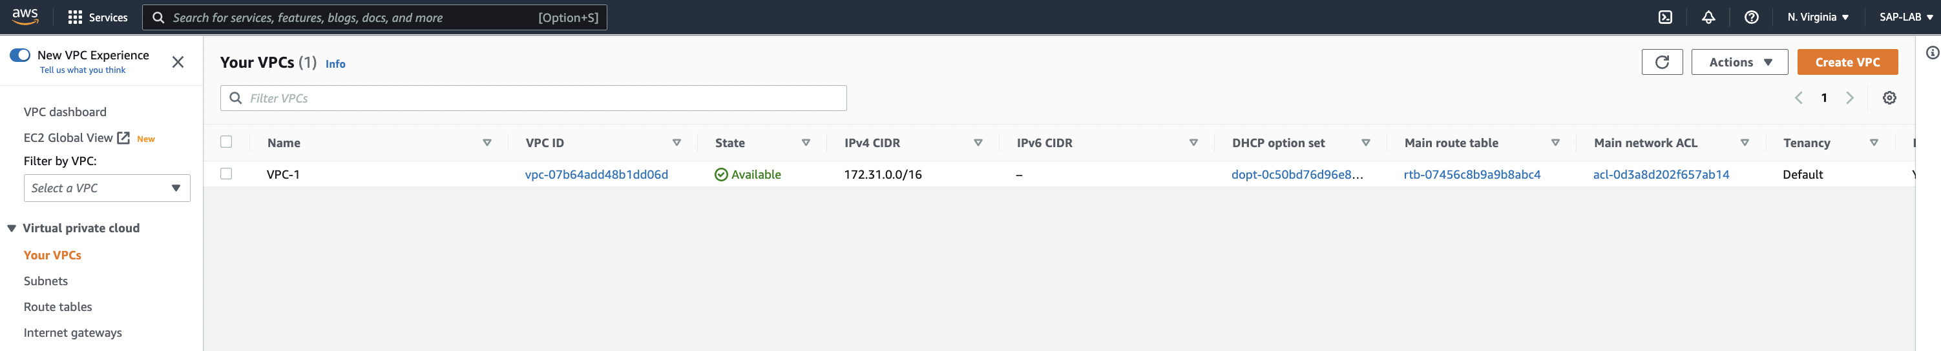

Step 2: Configure below properties for VPC, subnet creation in specific availability zone.

1. Resource to create: Choose ‘VPC and more’
2. Name tag auto-generation: Put the suitable name
3. IPv4 CIDR block: Put the IPv4 range for CIDR block
4. IPv6 CIDR block: Choose ‘No IPv6 CIDR block’
5. Tenancy – Choose ‘Default’
6. Number of availability Zone: Click on ‘1’ (As we do not need multiple AZ to perform this assignment, we can create 3 AZs if required with this configuration)
7. Number of Public Subnet: If we have 1 AZ, it will give option for 1 public subnet
8. Nat gateway -1
9. DNS options: Tick both the checkboxes

Click on ‘Create VPC’.

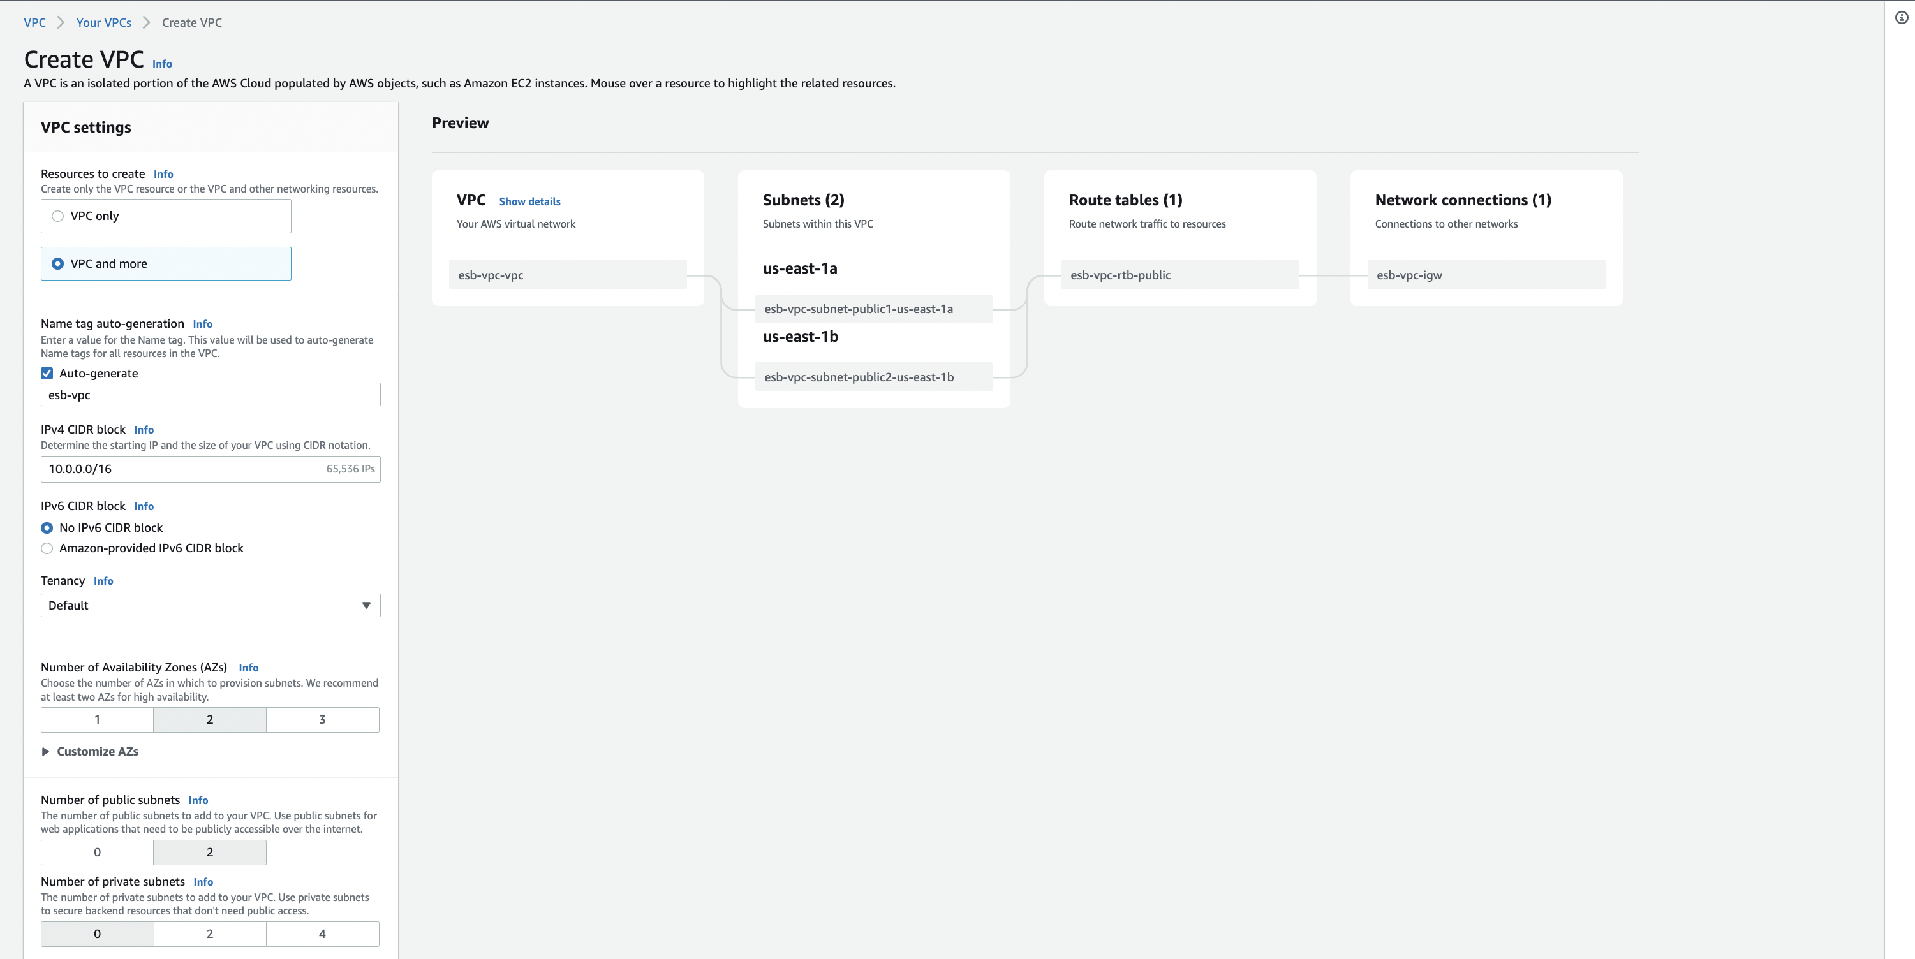

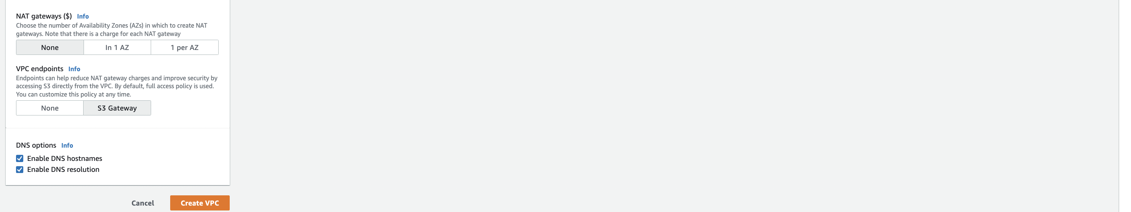

Upon successful creation of VPC, Subnets we will get creation ‘Success’ message on same screen as below.

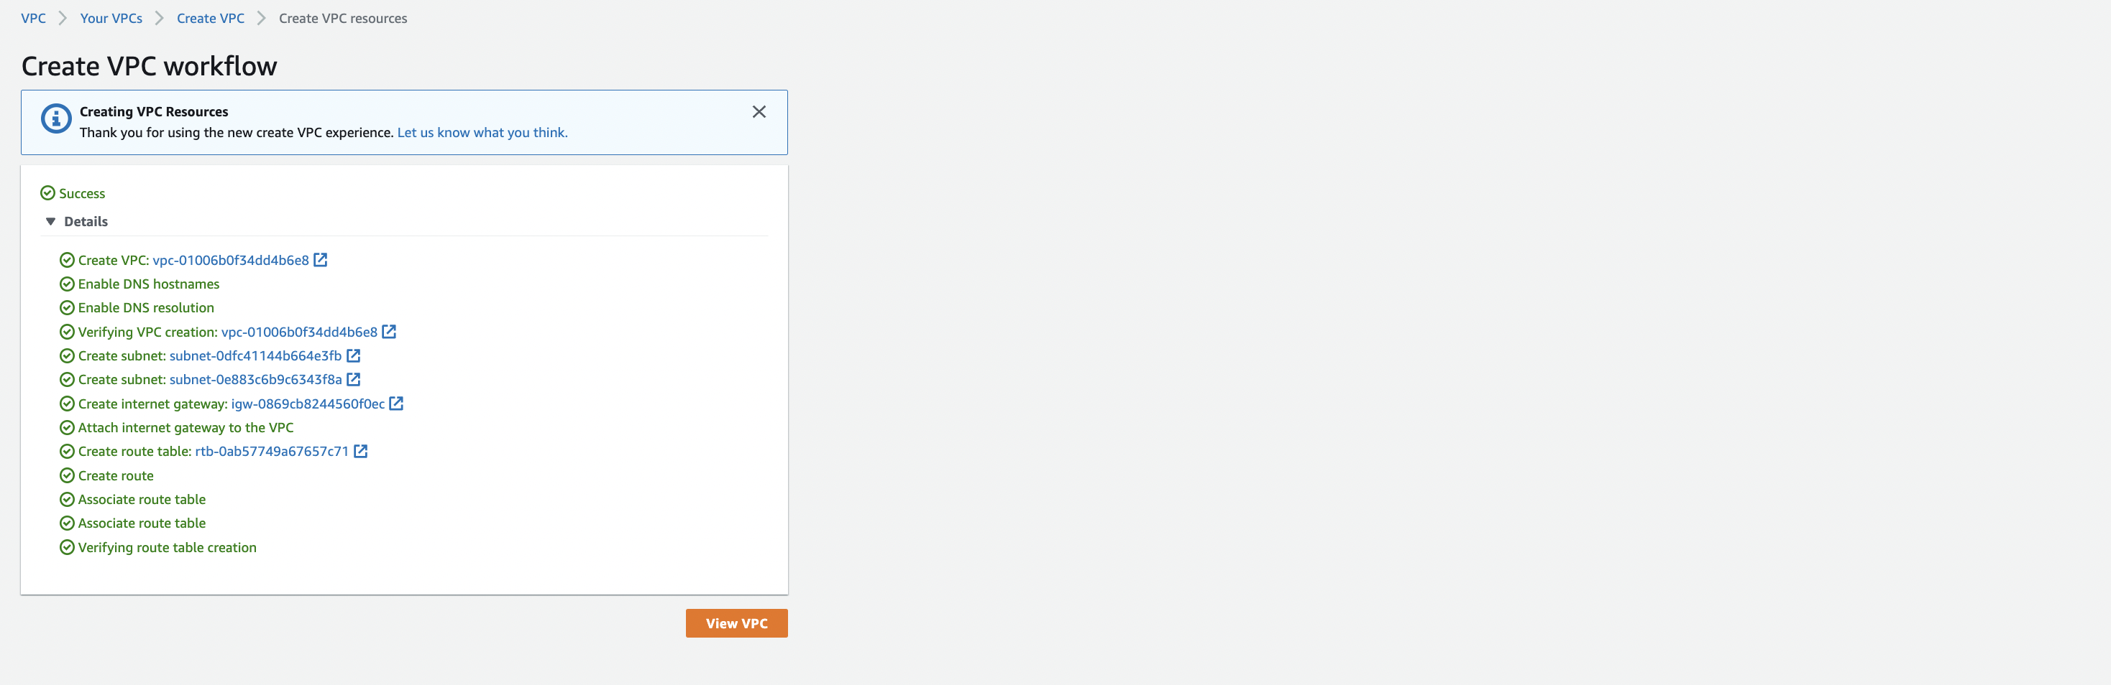

Step 3: Go EC2 instance dashboard, click on volume under Elastic Bean Storage section in left side pane.

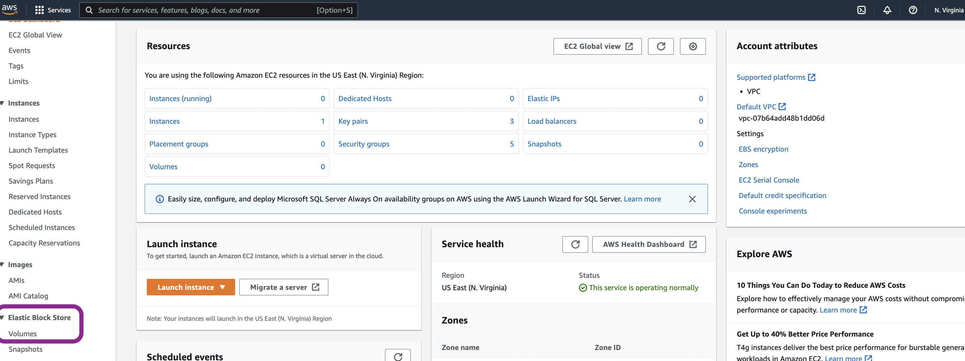

Step 4: Click on create volume and configure the below mandatory properties

1. Volume Type – General Purpose SSD (gp2)
2. Size – 10gb (to be in limit of free tier scope)
3. Availability zone – us-east-1b (keeping as per our already configured ec2 zone)
4. Tag (optional) – Key – Name

Value – Additional volume for ec2

and click on **create volume**.

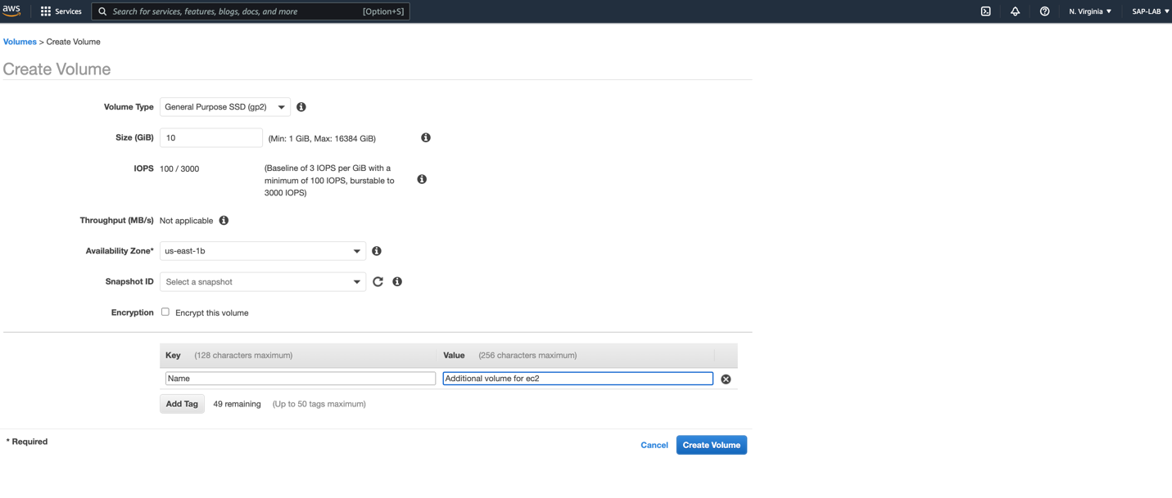

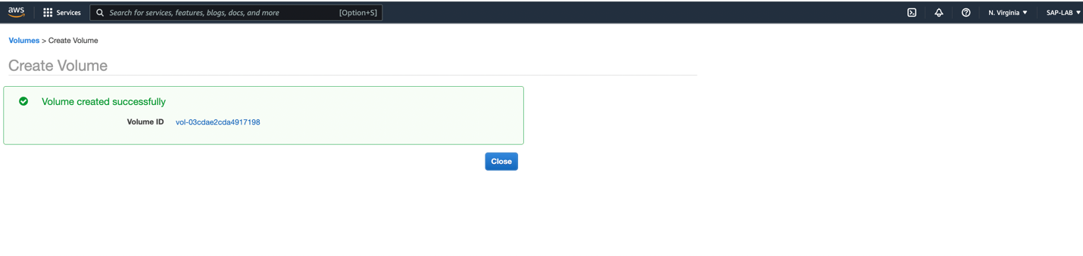

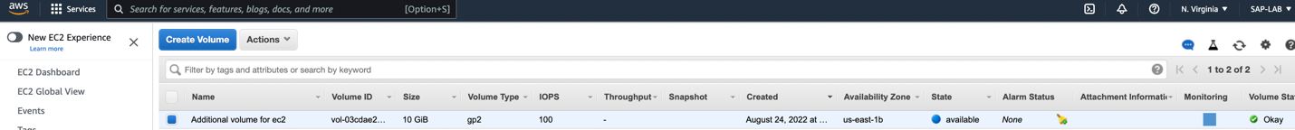

## Task 2 – Attaching EBS

Step 1: To attach the EBS in EC2, select the desired EBS Volume, click on ‘**Actions’**, click on ‘**Attach Volume**’.

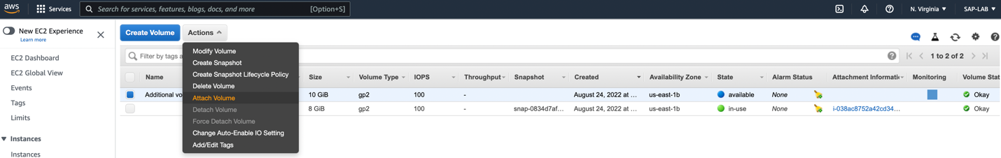

Step 2: Select the instance to attach the volume and click on ‘**Attach’**.

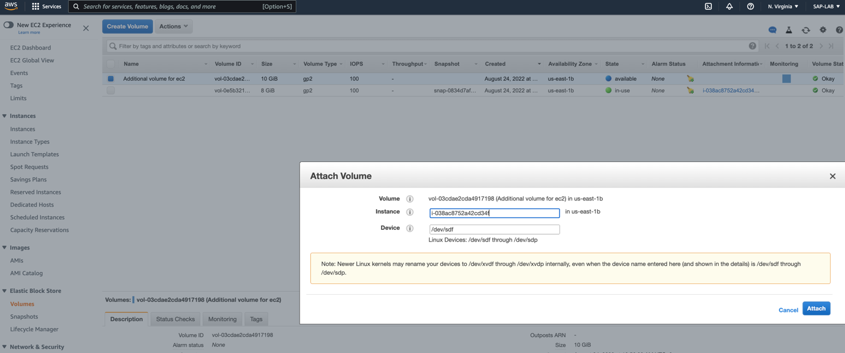

To verify, we can check the attachment information:

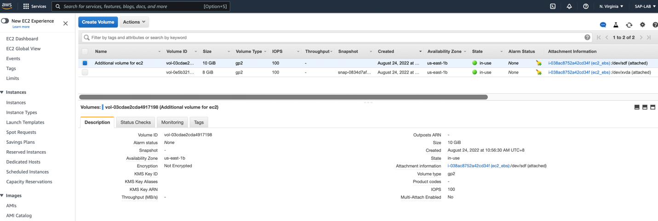

## Task 3 – To Access, Partition, Mount EBS Volume

To access to EBS volume we will connect to EC2, for that –

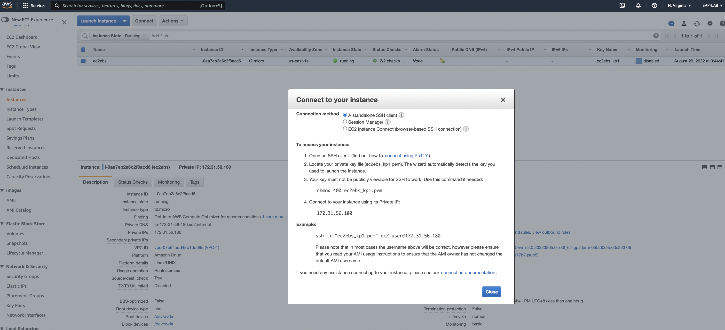

Step 1: Open SSH terminal, and open the directory where we have saved our key-pair file.

To modify public level access execute the below command:

Chmod 400 <key-pair filename>

Step 2: Open EC2 instance dashboard click on ‘Connect’, from the popped up window, copy the command to connect instance (after point 4) from example and execute in terminal:

**ssh -i "ec2ebs.pem" ec2-user@ec2-<Public-IP>.compute-1.amazonaws.com**

it will ask to continue with it. Input ‘yes’ and enter.

Step 3: Execute below commands to Access, partiotion, Mount attached storage block

1. to avoid any permission level issue, execute below command to work as root user:

**sudo su -l**

1. to see attached volumes:

**lsblk**

1. **To see file-system, mount point, UUID**

**lsblk -fs**

1. To create a mount point directory

**mkdir /tmp/images**

1. To check more information about disk

**fdisk -l**

1. To create a partition

fdisk <device name>

It will suggest commands for next actions

1. Enter ‘**m’** for help
2. Type **n** for ‘new partition’
3. Type **p** for ‘new partition
4. Press ‘Enter’ for default partition
5. Press ‘Enter’ for default partition number
6. Press ‘Enter’ for First sector
7. Press ‘Enter’ for allowing to creation partition of full size
8. Enter ‘**w’** for writing the changes
9. To inform kernel about partition changes

**partprobe**

1. To format filesystem

**mkfs.xfs /dev/xvdf1**

1. To verify and check mount point

**lsblk -fs**

1. To mount /dev/xvdf1 partiotion to the directory of tmp

**mount /dev/xvdf1 /tmp/images**

1. To verify again

**lsblk -fs**

After this whatever we will save in images, it will be saved on dev/xvdf1

1. Change directory to images

**cd /tmp/images**

1. To create .txt files on it

**touch testfiles1{1..10}.txt**

1. To verify files creation, use list command

**ls**

1. To make mount point persistent, go back to previous directory

**cd**

1. To make mount point persistent, we need to edit fstab file. To edit file in vi editor

**vi /etc/fstab**

Insert ‘**i**’ to go to insert mode

Then after UUID in next line enter

**/dev/xvdf1 /tmp/images xfs defaults 0 0**

Press ‘esc’ to switch the editor’s command mode and enter :x and press ‘enter button to save and exit the file.

1. To unmount

**umount /tmp/images**

1. To check used %

**df -h**

1. To mount

**mount -a**

1. To verify if filesystem has mounted

**lsblk -fs**

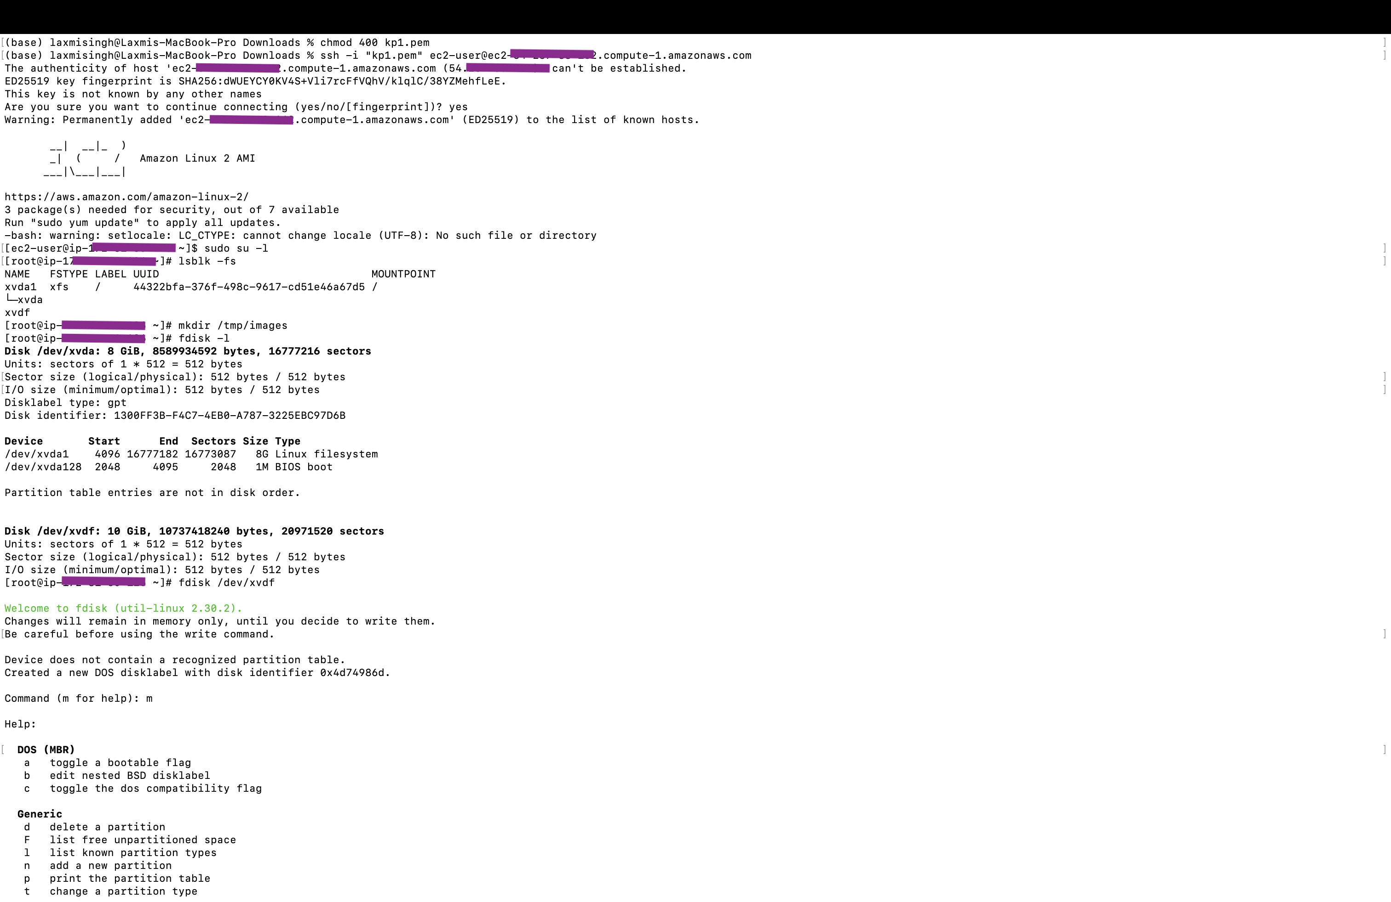

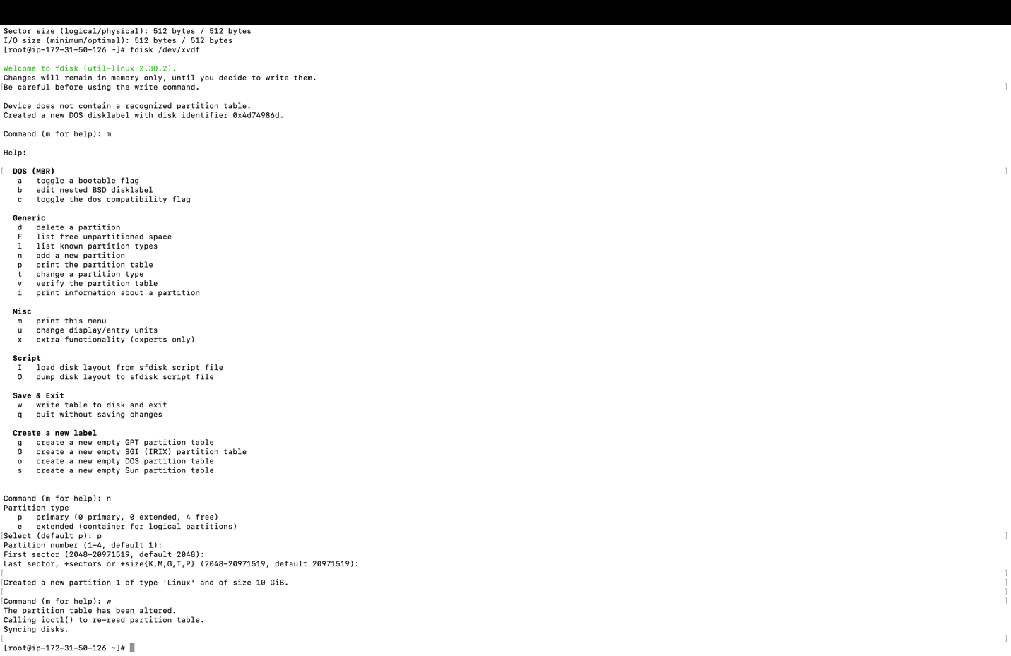

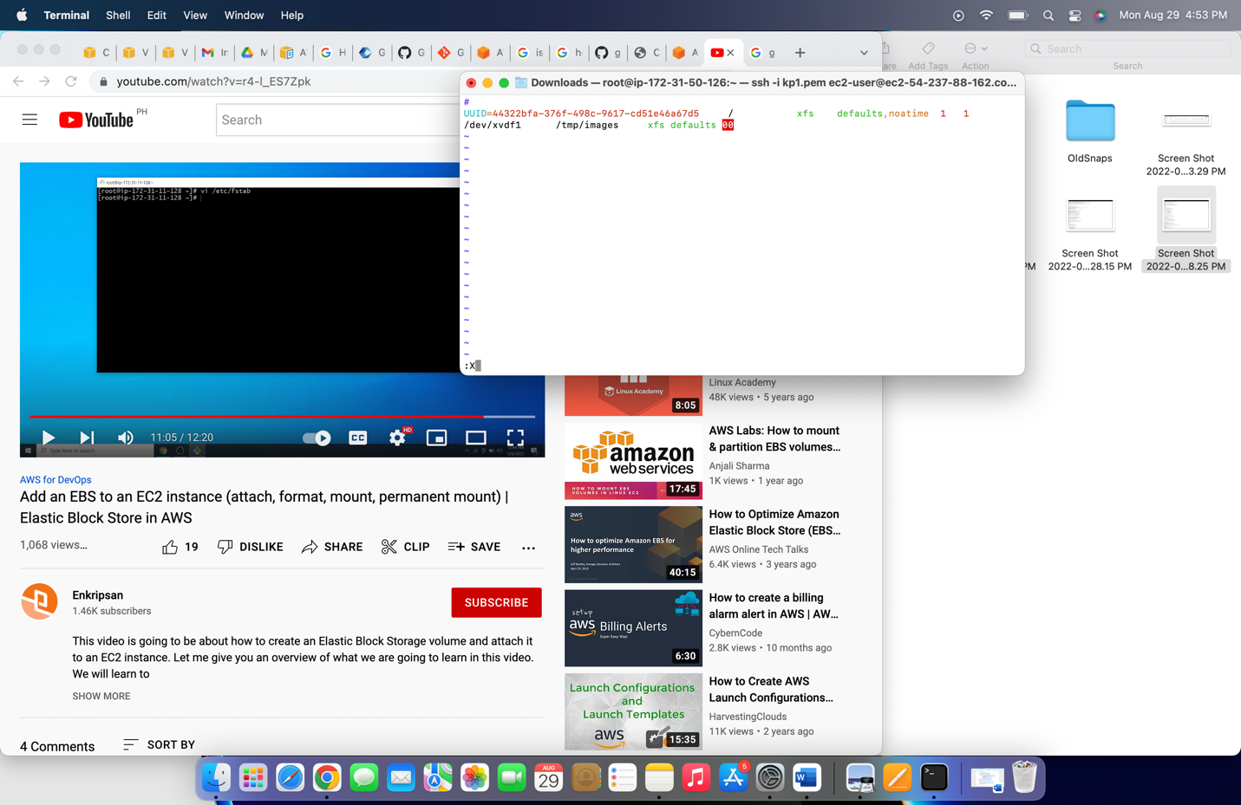

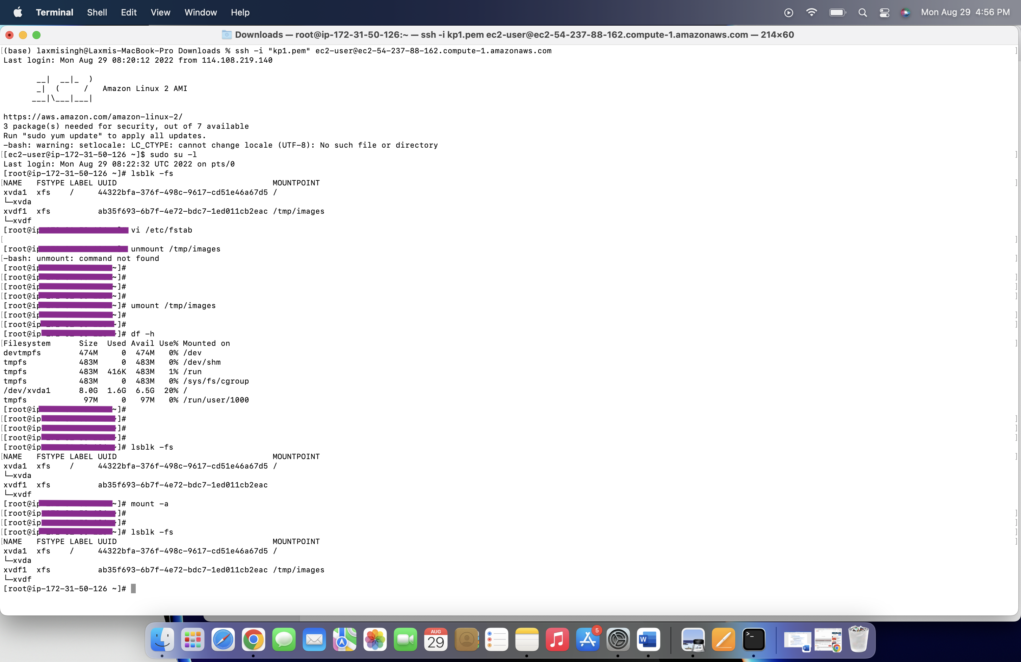

We attached and accessed filesystem through ssh. Portioned and mounted the disk in above commands successfully.